Executive Report  
SQL - Burlington Houses

short line

Big Money Inc.

TEL:867-5309

EMAIL:[bigmoney@hotmail.com](mailto:bigmoney@hotmail.com)

MEMBERS: David Thomsen // Micah Kezar

# Table of Contents

**Introduction 2**

**Executive Summary 2**

**Queries……………………………………………………………………….3****-7**

**Additional Questions** **.…………….……………………………………..8**

# 

# 

# Introduction

The purpose of this report is to understand Burlington housing data that has been stored within a SQL database. Our mission is to create questions that can be answered through queries of the database.

To recreate this database, please run the all_burl_properties script to generate the database. Then to run and test the queries, please run the Thomsen_Kezar_Queries.

# Executive Summary

We were provided with a script that will create the databases and tables necessary for this lab. We reverse engineered this model so that we could get an ERD to better understand relational information for this schema.

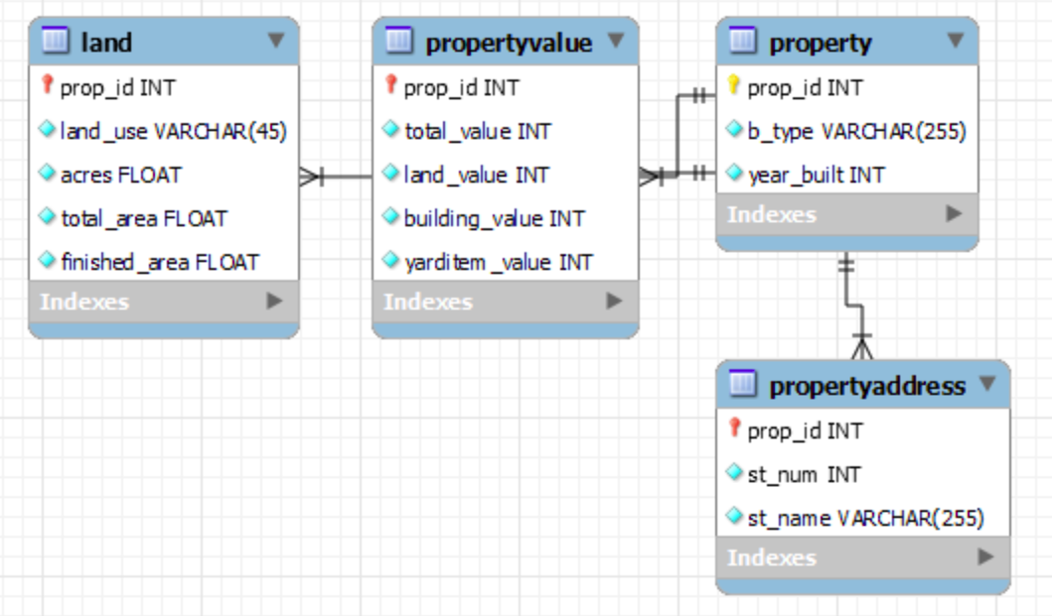

With this we were able to look at patterns within the database and come up with a strategy to query the database. Most of our queries are centered around pricing and the use of the houses within different streets around Burlington. The questions as well as the queries have been listed below.

# Queries

**Question 1**: Which property types (e.g., residential, commercial, industrial) dominate each street in Burlington?

**Objective**: Understand the diversity of property types on different streets.

**SQL Query**: Join the propertyaddress and property tables. Group properties by street name and count the occurrences of each property type.

use all_burl_properties;

SELECT

pa.st_name AS StreetName,

p.b_type AS PropertyType,

COUNT(*) AS PropertyCount

FROM

property p

JOIN

propertyaddress pa ON p.prop_id = pa.prop_id

GROUP BY

pa.st_name, p.b_type

ORDER BY

pa.st_name, PropertyCount DESC;

/* Sorts every street Alphabetically, and sorts the Property Type in DESC order by how many Properties of that Type exist on that Street */

short dash

**Question 2**: Are the wealthiest streets in Burlington characterized by diverse land uses?

**Objective**: Determine if high-value streets have a mix of residential, commercial, and other land uses.

**SQL Query**: Join the propertyaddress, property, and land tables. Examine land use distribution on top-valued streets.

USE all_burl_properties;

SELECT

pa.st_name AS StreetName,

GROUP_CONCAT(pa.st_num ORDER BY pa.st_num) AS CombinedStreetNumbers,

l.land_use AS LandUse,

SUM(pv.total_value) AS TotalValue

FROM

property p

JOIN

propertyaddress pa ON p.prop_id = pa.prop_id

JOIN

propertyvalue pv ON p.prop_id = pv.prop_id

JOIN

land l ON p.prop_id = l.prop_id

GROUP BY

pa.st_name, l.land_use

ORDER BY

pa.st_name, TotalValue DESC;

/* Combines any street number that uses the same Land Use, and grabs the Sum of the houses per Land Use. Sorts Streets by Alphabetical, and Total Value DESC */

short dash

**Question 3**:How do property values vary based on both property type (e.g., residential, commercial) and condition (e.g., excellent, fair)?

**Objective**: Understand the impact of property type and condition on overall value.

**SQL Query**: Join the property, propertyvalue, and land tables. Calculate average total value for each combination of property type and condition.

USE all_burl_properties;

SELECT

pa.st_name AS StreetName,

pa.st_num AS StreetNumber,

p.b_type AS PropertyType,

pv.total_value AS TotalValue

FROM

property p

JOIN

propertyaddress pa ON p.prop_id = pa.prop_id

JOIN

propertyvalue pv ON p.prop_id = pv.prop_id

GROUP BY

pa.st_name, pa.st_num, p.b_type, pv.total_value

ORDER BY

pa.st_name, pv.total_value DESC;

/* Sorts every street Alphabetically, and lists house type and house value (DESC) per street */

short dash

**Question 4**: Which street in Burlington has the highest property values? Conversely, which street is considered the poorest in terms of property value? Are there any notable trends or characteristics associated with these streets?

**Objective**: Understand the relationship between highest property values and the lowest property values to determine a cause for this relationship.

**SQL Query**: Join the propertyaddress and propertyvalue tables. Group properties by street name and order by total property values for each street.

USE all_burl_properties;

SELECT

pa.st_name AS StreetName,

GROUP_CONCAT(pa.st_num ORDER BY pa.st_num) AS CombinedStreetNumbers,

SUM(pv.total_value) AS TotalValue

FROM

property p

JOIN

propertyaddress pa ON p.prop_id = pa.prop_id

JOIN

propertyvalue pv ON p.prop_id = pv.prop_id

GROUP BY

pa.st_name

ORDER BY

pa.st_name, TotalValue DESC;

short dash

**Question 5**: Is there a correlation between specific land use types and higher property values and what is the average price?

**Objective**: Understand the relationship between land use and property values.

**SQL Query**: Shows the relation of Land usage, Average Land Price, and the Streets that use the land.



USE all_burl_properties;

SELECT

LU.land_use,

CONVERT(AVG(PV.total_value), DECIMAL(10, 2)) AS avg_property_value_rounded,

pa.st_name AS StreetName

FROM

land LU

JOIN

propertyvalue PV ON LU.prop_id = PV.prop_id

JOIN

property p ON LU.prop_id = p.prop_id

JOIN

propertyaddress pa ON p.prop_id = pa.prop_id

GROUP BY

LU.land_use, pa.st_name

ORDER BY

avg_property_value_rounded DESC, StreetName;

short dash

# Additional Questions:

**Do we want to redesign the database for functionality or issues that came up?**

* No, we had little issue interfacing with the database using its current schema. Redesigning it would be much more work than is necessary for this type of data.

**Database Design & Analysis (12 points)**

* Did you select questions for analysis that meet the criteria of the questions asked for in this assignment?
  + Yes we selected multiple questions related to the prices, location, and usage of the land and properties within Burlington. We have five specific questions that can be answered with the use of queries.
* Does your code support providing information to help answer your questions?
  + Yes, the code brings up relevant and contextual information that is needed to answer the questions that are being asked.

**SQL (6 points)**

* Did you properly use SQL syntax?
  + Yes, all of the code that has been provided runs and will be attached as a script file in addition to this report.
* Was your SQL of a clean style?
  + Yes, each of the queries has an accompanying question(s) as well as running all within a script with no errors or hangups.
* Was your SQL of the sophistication necessary to complete the analysis?
  + We believe that with our current understanding of databases and the SQL languages these were sophisticated enough to apply what has been learned within class, as well as explore and answer questions that relate to this assignment.
* Did it meet the criteria laid out in this document?
  + **Criteria**: Your goal is to develop at least 5 questions you have about the properties listed in the database. The database is saved in a .zip file on Canvas. The name of the .zip file is all_burl_properties.zip and should be downloaded from Canvas. Your questions should be specific and have a clear result sought.
  + I believe that we accomplished the criteria that have been set within this assignment. We created five specific questions that dive into queries to answer them clearly and contextually.

**Report (2 points)**

* Did your report coherently explain your project?
  + Yes. We began with an overall objective of the assignment, then begin to describe our goal as well as our queries. Then all of the additional questions that were asked about specific parts of the assignment were covered.
* Does your report show an understanding of database design principles and MySQL?
  + Yes as all of the tools and methods that we have learned so far have been utilized in this project. From installation of workbench and an SQL server on our personal machines, running the script to create the schema, reverse engineering the schema to make an ERD, or creating queries, all of this was covered in this project.
* Does your report meet the requirements outlined in this document?
  + **Requirements:** Your final report should include three files. One must your ERD of the database. The ERD must include a view of the tables, their respective attributes, keys and datatypes. The suggested file you submit is the Workbench file that holds your ERD. Another file should be a .zip or type of compression file that contains all of your SQL code. The other should be a short report (2-4 pages) explaining your project’s goals, its results, and how you used MySQL. Be sure to include your results tables in the report, nicely formatted for human consumption.
  + Other than the length of the report (we included the code which added multiple additional pages), we covered all of this and the final deliverable will be an ERD, the SQL Script File, and this Report.